**计算器实验报告**

一．计算器界面及操作

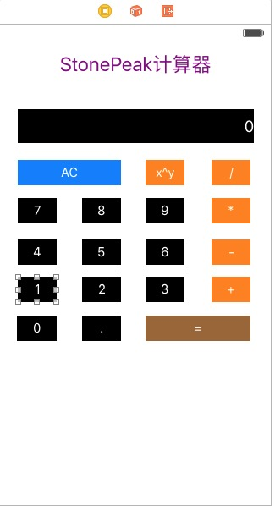

实现计算器的基本功能，并处理了简单的bug，小数点问题，多次输入.的问题等。

1. 项目目录

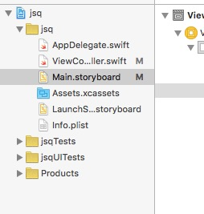

三·代码及功能

//

// ViewController.swift

// jsq

//

// Created by dou on 16/3/17.

// Copyright :emoji: 2016年 stonepeak. All rights reserved.

//

import UIKit

class ViewController: UIViewController {

@IBOutlet weak var resultLable: UILabel!

var n1: String = ""

var n2: String = ""

var pointLoop: Bool = false

var operand: String = ""

override func viewDidLoad() {

super.viewDidLoad()

// Do any additional setup after loading the view, typically from a nib.

}

override func didReceiveMemoryWarning() {

super.didReceiveMemoryWarning()

// Dispose of any resources that can be recreated.

}

@IBAction func button(sender: UIButton) {

let value = sender.currentTitle!

if value == "AC" {

n1 = ""

n2 = ""

resultLable.text = ""

return

} else if value == "+"||value == "-"||value == "*"||value == "/"||value == "x^y"{

operand = value

resultLable.text = ""

return

}else if value == "="{

var result = 0.0

switch operand{

case "+":

result = Double(n1)! + Double(n2)!

resultLable.text = "result"

case "-":

result = Double(n1)! - Double(n2)!

resultLable.text = "result"

case "*":

result = Double(n1)! * Double(n2)!

resultLable.text = "result"

case "/":

result = Double(n1)! / Double(n2)!

resultLable.text = "result"

case "x^y":

result=1;

for(var c=0; c < (Int)(n2) ;c++)

{

result = result * Double(n1)!

}

resultLable.text = "result"

default:

result = 0

}

resultLable.text = "\(result)"

operand = ""

n1 = ""

n2 = ""

return

}

if operand == ""{

n1 = n1 + value

resultLable.text = "\(n1)"

return

}

else {

n2 = n2 + value

resultLable.text = "\(n2)"

return

}

}

@IBAction func point(sender: UIButton) {

if(!pointLoop)

{

if(!(resultLable.text! == "")){

resultLable.text! += "."

pointLoop=true

}

}

}

}

20131105818

13软件

石峰